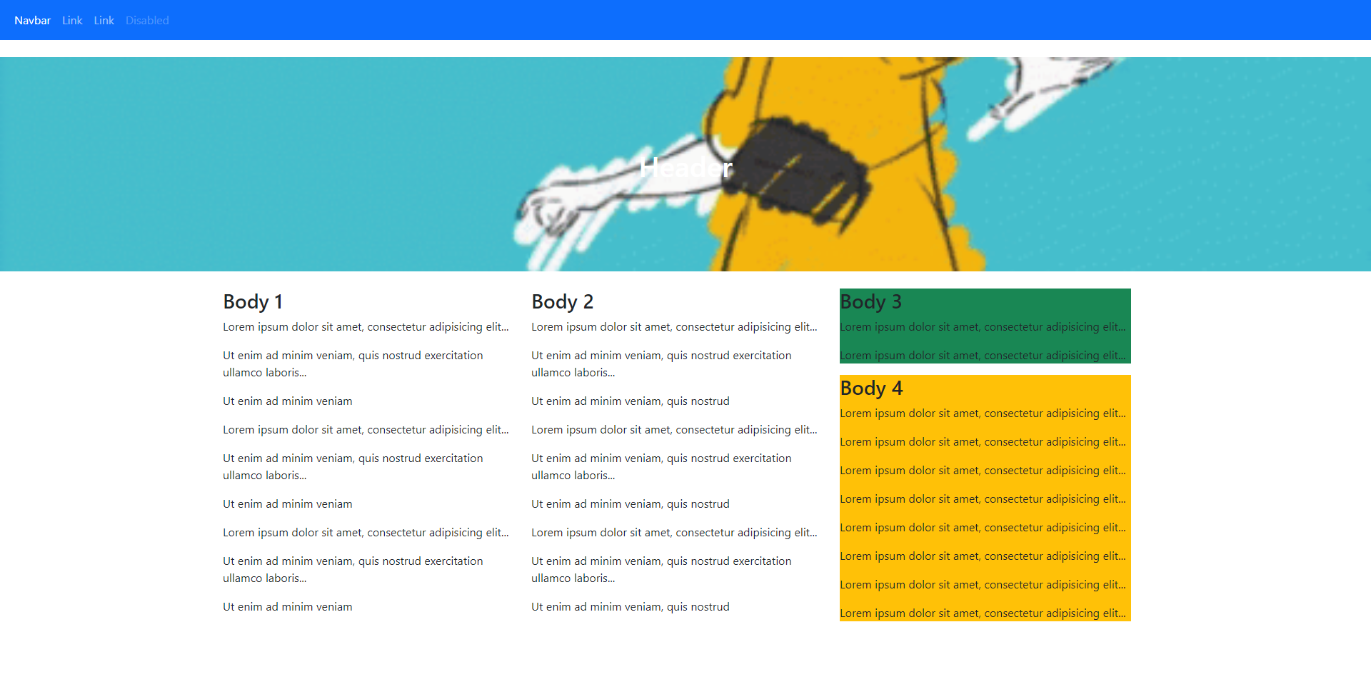

<!DOCTYPE html>

<html lang="en">

<head>

    <link rel="stylesheet" href="css/bootstrap.min.css">

    <link rel="stylesheet" href="css/custom.css">

</head>

<body>

    <link href="https://cdn.jsdelivr.net/npm/bootstrap@5.1.2/dist/css/bootstrap.min.css" rel="stylesheet">

    <script src="https://cdn.jsdelivr.net/npm/bootstrap@5.1.2/dist/js/bootstrap.bundle.min.js"></script>

  </head>

  <body>

  <nav class="navbar navbar-expand-sm bg-primary navbar-dark">

    <div class="container-fluid">

      <ul class="navbar-nav">

        <li class="nav-item">

          <a class="nav-link active" >Navbar</a>

        </li>

        <li class="nav-item">

          <a class="nav-link" href="#">Link</a>

        </li>

        <li class="nav-item">

          <a class="nav-link" href="#">Link</a>

        </li>

        <li class="nav-item">

          <a class="nav-link disabled" href="#">Disabled</a>

        </li>

      </ul>

    </div>

  </nav>

      <br>

      <!--Header-->

      <header class="text-white text-center">

        <div class="container">

            <div class="row">

                <div class="col-xl-9 mx-auto">

                    <h1 class="mb-5">Header</h1>

                </div>

                <div class="col-md-10 col-lg-8 col-xl-7 mx-auto">

                    <div class="text-center mx-auto">

                    </div>

                </div>

                </form>

            </div>

        </div>

        </div>

    </header>

    <br>

    <!--body-->

    <div class="container">

        <div class="row">

        <div class="row row-cols-2">

          <div class="col-sm-4">

            <h3>Body 1</h3>

            <p>Lorem ipsum dolor sit amet, consectetur adipisicing elit...</p>

            <p>Ut enim ad minim veniam, quis nostrud exercitation ullamco laboris...</p>

            <p>Ut enim ad minim veniam</p>

            <p>Lorem ipsum dolor sit amet, consectetur adipisicing elit...</p>

            <p>Ut enim ad minim veniam, quis nostrud exercitation ullamco laboris...</p>

            <p>Ut enim ad minim veniam</p>

            <p>Lorem ipsum dolor sit amet, consectetur adipisicing elit...</p>

            <p>Ut enim ad minim veniam, quis nostrud exercitation ullamco laboris...</p>

            <p>Ut enim ad minim veniam</p>

          </div>

          <div class="col-sm-4">

            <div class="col bg-success"></div>

            <h3>Body 2</h3>

            <p>Lorem ipsum dolor sit amet, consectetur adipisicing elit...</p>

            <p>Ut enim ad minim veniam, quis nostrud exercitation ullamco laboris...</p>

            <p>Ut enim ad minim veniam, quis nostrud</p>

            <p>Lorem ipsum dolor sit amet, consectetur adipisicing elit...</p>

            <p>Ut enim ad minim veniam, quis nostrud exercitation ullamco laboris...</p>

            <p>Ut enim ad minim veniam, quis nostrud</p>

            <p>Lorem ipsum dolor sit amet, consectetur adipisicing elit...</p>

            <p>Ut enim ad minim veniam, quis nostrud exercitation ullamco laboris...</p>

            <p>Ut enim ad minim veniam, quis nostrud</p>

          </div>

          <div class="col-sm-4">

          <div class="col bg-success">

          <h3>Body 3</h3>

            <p>Lorem ipsum dolor sit amet, consectetur adipisicing elit...</p>

            <p>Lorem ipsum dolor sit amet, consectetur adipisicing elit...</p>

            </div>

            <div class="col-sm-12">

          <div class="col bg-warning">

          <h3>Body 4</h3>

            <p>Lorem ipsum dolor sit amet, consectetur adipisicing elit...</p>

            <p>Lorem ipsum dolor sit amet, consectetur adipisicing elit...</p>

            <p>Lorem ipsum dolor sit amet, consectetur adipisicing elit...</p>

            <p>Lorem ipsum dolor sit amet, consectetur adipisicing elit...</p>

            <p>Lorem ipsum dolor sit amet, consectetur adipisicing elit...</p>

            <p>Lorem ipsum dolor sit amet, consectetur adipisicing elit...</p>

            <p>Lorem ipsum dolor sit amet, consectetur adipisicing elit...</p>

            <p>Lorem ipsum dolor sit amet, consectetur adipisicing elit...</p>

               </div>

        </div>

      </div>

    <script src="js/bootstrap.min.js"></script>

</body>

</html>

css

header {

    background: url('../img/bg.jpg') no-repeat center center;

    background-size: cover;

    padding-top: 8rem;

    padding-bottom: 8rem;

    height: 300px;

}